**DEEP LEARNING FUNDUS IMAGE ANALYSIS FOR EARLY DETECTION OF DIABETIC RETINOPATHY**

**Submitted by,**

**Kumar S S**

**Deep Learning Fundus Image Analysis for Early Detection of Diabetic Retinopathy**

**1. INTRODUCTION**

**1.1 Overview**

Diabetic Retinopathy (DR) stands as a significant public health concern, particularly among individuals diagnosed with diabetes. This condition, characterized by damage to the retina due to prolonged exposure to high blood sugar levels, is a leading cause of blindness worldwide. Early detection and intervention are pivotal in preventing irreversible vision impairment. The traditional methods of DR screening, often reliant on manual examination of fundus images by healthcare professionals, are not only time-consuming but also prone to subjective interpretations. the International Clinical Diabetic Retinopathy (ICDR) levels are, No Apparent Retinopathy: No abnormalities; Mild Non-Proliferative Diabetic Retinopathy (NPDR): This is the first stage of diabetic retinopathy, specifically characterized by tiny areas of swelling in retinal blood vessels known as Microaneurysms; Moderate NPDR: When left unchecked, mild NPDR progresses to a moderate stage when there is blood leakage from the blocked retinal vessels ; Severe NPDR: A larger number of retinal blood vessels are blocked in this stage and Proliferative Diabetic Retinopathy (PDR): This is an advanced stage of the disease that occurs when the condition is left unchecked for an extended period of time.

In response to these challenges, the integration of advanced technologies, particularly Deep Learning (DL), has emerged as a transformative approach to enhance the efficiency and accuracy of DR diagnosis. This project focuses on leveraging the capabilities of DL, specifically employing the Xception neural network, to develop an automated system for the early detection of diabetic retinopathy through the analysis of fundus images.

**1.2 Purpose**

DR begins at a mild level with no apparent visual symptoms but it can progress to severe and proliferated levels and progression of the disease can lead to blindness. Thus, early diagnosis and regular screening can decrease the risk of visual loss to 57.0% as well as decreasing the cost of treatment [1]. The primary purpose of this project is to bridge the gap between the growing prevalence of diabetic retinopathy and the limitations of traditional screening methods. By integrating deep learning, it is aimed to create a system that not only expedites the screening process but also enhances the accuracy of detection. Early identification of diabetic retinopathy allows for timely medical intervention, potentially preventing the progression of the disease and minimizing the risk of irreversible vision loss. The integration of the Xception neural network, known for its exceptional performance in image classification tasks, signifies a strategic choice aimed at achieving state-of-the-art results in diabetic retinopathy detection.

**2. LITERATURE SURVEY**

**2.1 Existing Problem**

The traditional methods of diabetic retinopathy (DR) screening, predominantly reliant on manual examination of fundus images, have been facing persistent challenges. The human-intensive nature of this approach makes it prone to subjectivity and variability in diagnostic interpretations. Several existing works have employed machine learning (ML) techniques for feature extraction and decision-making in constructing models for diabetic retinopathy (DR) detection. Across these studies, six major ML algorithms were identified. These include principal component analysis (PCA) [2, 3], linear discriminant analysis (LDA)-based feature selection [3], spatial invariant feature transform (SIFT) [3], support vector machine (SVM) [4], k nearest neighbor (KNN) [5], and random forest (RF) [6]. In addition to these commonly used ML methods, a study by [7] introduced a pure ML model achieving an accuracy of over 80%. This model incorporated distributed Stochastic Neighbor Embedding (t-SNE) for image dimensionality reduction, coupled with an ML Bagging Ensemble Classifier (ML-BEC). The ML-BEC enhances classification performance through feature bagging while maintaining low computational time.

Another study conducted by Ali et al. [8] focused on five fundamental ML models: sequential minimal optimization (SMO), logistic (Lg), multi-layer perceptron (MLP), logistic model tree (LMT), and simple logistic (SLg) at the classification level. This study proposed a novel preprocessing method involving the segmentation of the Region of Interest (ROI) of lesions using clustering-based methods and K-Means. Subsequently, Ali et al. [8] extracted features from the segmented ROIs, including histogram, wavelet, grey scale co-occurrence, and run-length matrices (GLCM and GLRLM).

Several studies suggest the development of deep learning networks, exemplified by the research conducted by Gulshan et al. [9], Gargeya et al. [10], Rajalakshmi et al. [11], and Riaz et al. [12]. While these customized networks may exhibit lower performance compared to state-of-the-art networks like VGG, ResNet, Inception, and DenseNet, their advantage lies in having fewer layers. This characteristic enhances their generalization, rendering them suitable for training with smaller datasets and ensuring computational efficiency.

The machine learning (ML) methods employed in diabetic retinopathy (DR) detection, including PCA, SIFT, LDA, SVM, KNN, and random forest, exhibit several limitations. Dependence on feature selection techniques and manual engineering may lead to the exclusion of crucial information and hinder scalability. Limited generalization across diverse datasets, sensitivity to hyperparameters, and challenges in adapting to complex image patterns are notable concerns. Some models, like SVM and random forest, can be computationally demanding, limiting deployment in resource-constrained environments. Additionally, the risk of overfitting, interpretability challenges, and the potential for ethnic and demographic bias underscore the need for continuous exploration of advanced techniques, incorporation of deep learning approaches, and comprehensive evaluations on diverse datasets to enhance the accuracy and reliability of DR detection models.

**2.2 Proposed Solution**

The proposed solution involves the application of Deep Learning techniques, specifically utilizing the Xception neural network, to automate the process of diabetic retinopathy detection in fundus images. DL has demonstrated remarkable success in various image analysis tasks, making it a promising candidate for transforming medical diagnostics. By leveraging the capabilities of DL, this project aims to create a system that can analyze fundus images with speed, precision, and consistency, addressing the limitations of manual screening.

Xception, a deep neural network architecture known for its exceptional performance in image classification, is chosen as the primary tool for feature extraction. Transfer learning techniques are employed to fine-tune the Xception model specifically for diabetic retinopathy detection. The intent is to capitalize on the pre-trained weights of Xception, which were obtained from a large dataset, to enhance the model's ability to generalize across diverse fundus images. This approach aligns with the broader trend in the literature that advocates for the use of pre-trained models to boost the performance of deep learning applications, particularly in the medical imaging domain.

**3. THEORETICAL ANALYSIS**

The theoretical analysis is succinctly represented through a block diagram that illustrates the interconnectedness of project components. The Xception model, with its deep architecture and parameter efficiency, plays a central role in feature extraction. The block diagram encapsulates the user interaction, model integration, and the subsequent prediction showcasing, providing a holistic view of the project's architecture. The seamless integration of data pre-processing, model building, and application development is evident, reflecting a well-thought-out and systematic approach. Technical architecture of the proposed system is shown in figure 1.

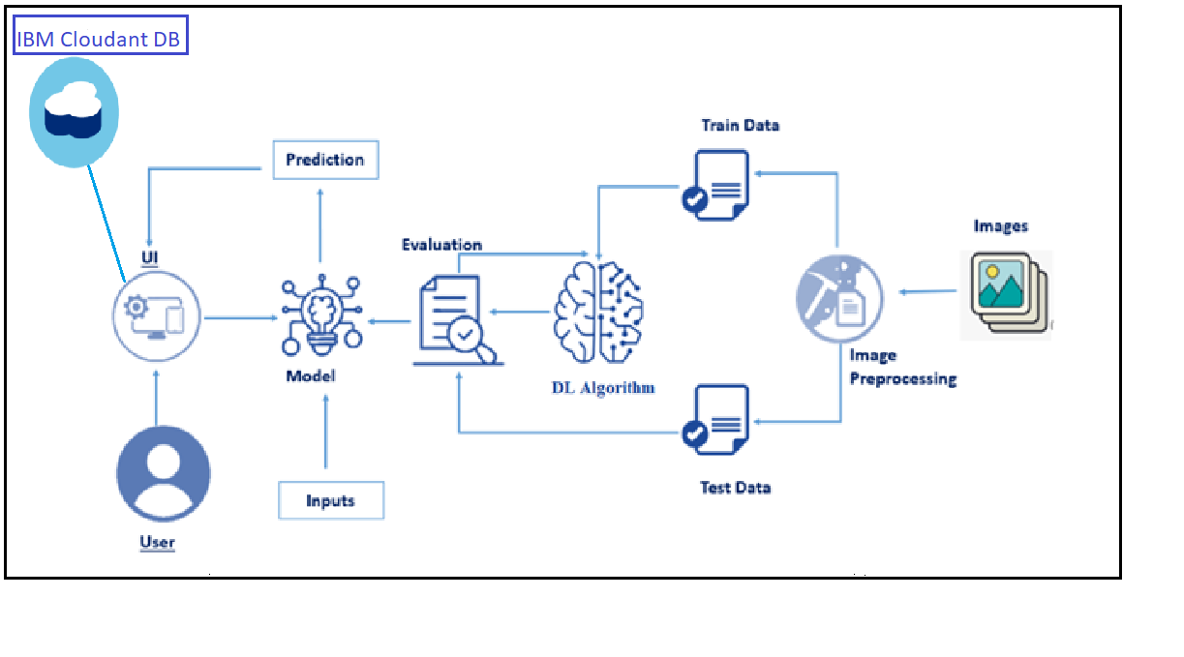

Figure 1: Technical Architecture:

The project unfolds with a user-centric approach, emphasizing the seamless interaction between the User Interface (UI), Flask application, and the Xception model for the early detection of diabetic retinopathy through fundus image analysis. The process commences with users engaging with the UI, where they select fundus images for analysis. This step is critical as it establishes a direct connection between healthcare professionals and the deep learning model. The Flask application serves as the intermediary, facilitating the integration of the chosen image with the Xception model.

The chosen image undergoes a meticulous analysis by the Xception model, which is renowned for its efficacy in image classification tasks. The model has been specifically fine-tuned for the early detection of diabetic retinopathy, making it a valuable asset in the fight against vision loss due to diabetes. The results of the analysis are then showcased on the Flask UI, providing healthcare professionals with an intuitive and user-friendly interface to interpret the model's predictions. This user-centric design is crucial in promoting the adoption of automated systems in the medical field, ensuring that even those without extensive technical backgrounds can benefit from advanced technologies.

The chosen dataset, Diabetic Retinopathy Level Detection from Kaggle, serves as the foundational source of information. Notably, the dataset is already organized into separate training and testing folders, streamlining the initial phases of the project. Data pre-processing, a pivotal step in any deep learning project, involves configuring the ImageDataGenerator class. This class is instrumental in augmenting the dataset, introducing variations that enhance the model's ability to generalize and recognize diverse patterns within fundus images.

Model building is a multifaceted process that involves leveraging the capabilities of the Xception model. As a pre-trained convolutional neural network (CNN), Xception acts as a feature extractor, capturing intricate patterns indicative of diabetic retinopathy. The integration with Flask signifies the real-world applicability of the model, allowing seamless communication between the UI, model, and application. The model is trained over 30 epochs, with careful consideration given to saving the model state after each epoch if it achieves the least loss encountered until that point. Testing the model against a separate dataset evaluates its performance, providing insights into accuracy and generalization capabilities. The created model is shown in Figure 2

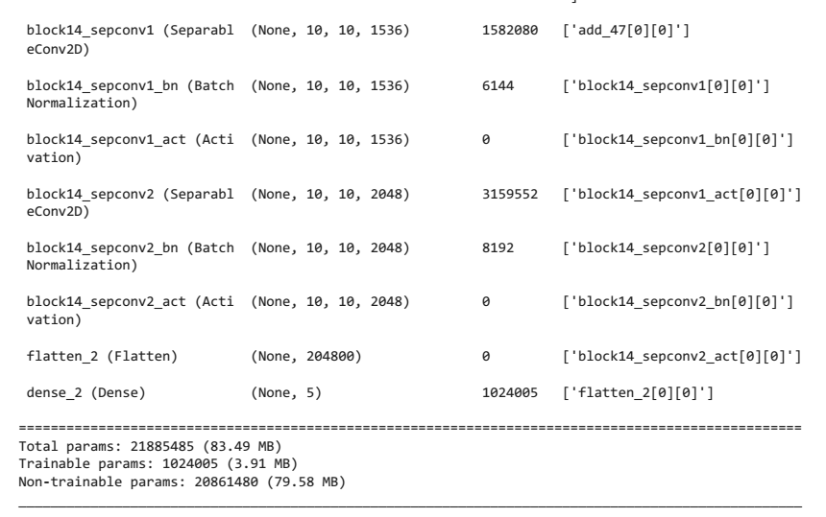

Figure 2 Model Summary

Application building involves creating an HTML file for the UI and developing Python code to handle user interactions, integrate the Xception model, and showcase predictions on the Flask UI. These components collectively contribute to the creation of a comprehensive system that is not only technically robust but also user-friendly, ensuring effective adoption in a medical context. The user interface for testing the image is given in Figure 3.

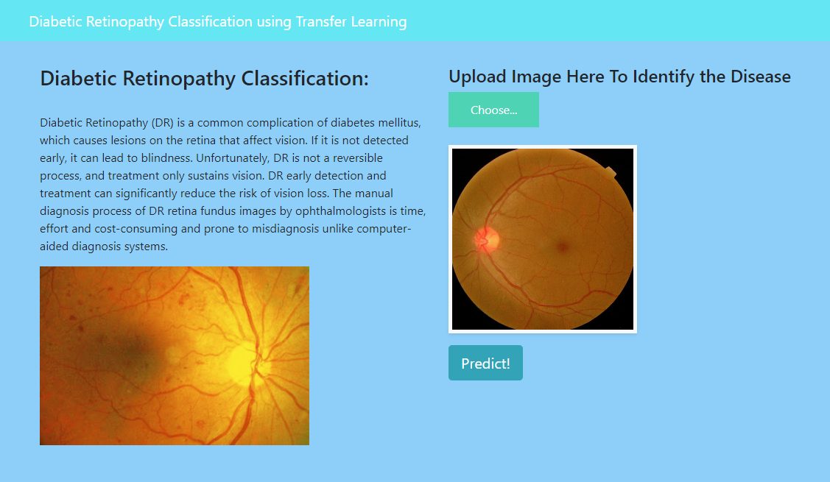

Figure 3 User Interface for Testing

**4. EXPERIMENTAL INVESTIGATIONS**

**4.1 Dataset**

The success of any deep learning model hinges on the quality and diversity of the dataset used for training and evaluation. In this project, the Diabetic Retinopathy Level Detection dataset sourced from Kaggle is employed. This dataset comprises a collection of fundus images annotated for diabetic retinopathy at various severity levels. The inclusion of diverse cases allows the model to learn and generalize across a spectrum of retinopathy conditions, enhancing its ability to detect subtle abnormalities in real-world scenarios.

**4.2 Implementation Details**

**4.2.1 Data Pre-processing**

Fundus images are inherently complex, and effective pre-processing is essential for model performance. The images are resized to the input dimensions expected by the Xception model (299x299 pixels). Normalization is applied to ensure that pixel values fall within a standardized range, preventing issues related to varying image intensities. The ImageDataGenerator class, a crucial component in data augmentation, is configured to introduce variations in the training set, simulating real-world scenarios and enhancing the model's robustness.

**4.2.2 Model Building**

The Xception model, chosen for its deep architecture and parameter efficiency, serves as the backbone for feature extraction. Transfer learning is employed by initializing the model with pre-trained weights on a large dataset (e.g., ImageNet). This pre-training provides the model with a head start in learning relevant features, particularly useful when working with a limited medical dataset. The final layers of the Xception model are customized to suit the diabetic retinopathy classification task. A dense layer with softmax activation is added to produce the final classification output.

**4.2.3 Training Process**

The model is trained using the configured dataset and architecture. The compilation step involves defining the loss function, optimizer, and metrics. Given the nature of the binary classification task (presence or absence of diabetic retinopathy), binary cross-entropy serves as an appropriate loss function. The Adam optimizer is chosen for its efficiency in updating model weights during training. Metrics such as accuracy and loss are monitored to gauge the model's performance.

The training process involves iterating over the dataset multiple times (epochs), with the model adjusting its weights based on the computed loss. Training progress is monitored, and model checkpoints are saved to capture the state of the model with the lowest loss encountered. This strategy ensures that the best-performing model is retained for subsequent evaluation. The training process is shown in Figure 4.

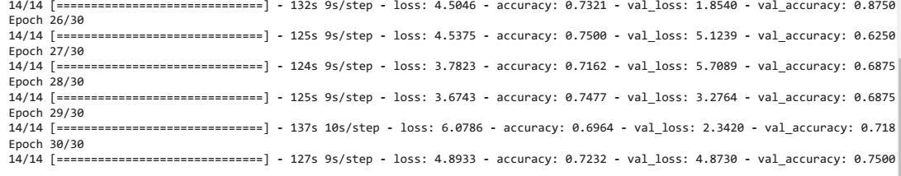

Figure 4. Training process

**4.2.4 Testing the Model**

The trained model is evaluated using a separate test dataset that the model has not seen during training. This step is crucial for assessing the model's generalization capabilities and its ability to perform well on unseen data.

**5 RESULTS**

The model's quantitative performance is assessed through a range of metrics, providing a nuanced understanding of its strengths and limitations. Accuracy serves as a fundamental measure of overall correctness. The highest validation accuracy obtained is 87 % with validation loss of 1.850. Figure 4 shows the predicted output for one test case.

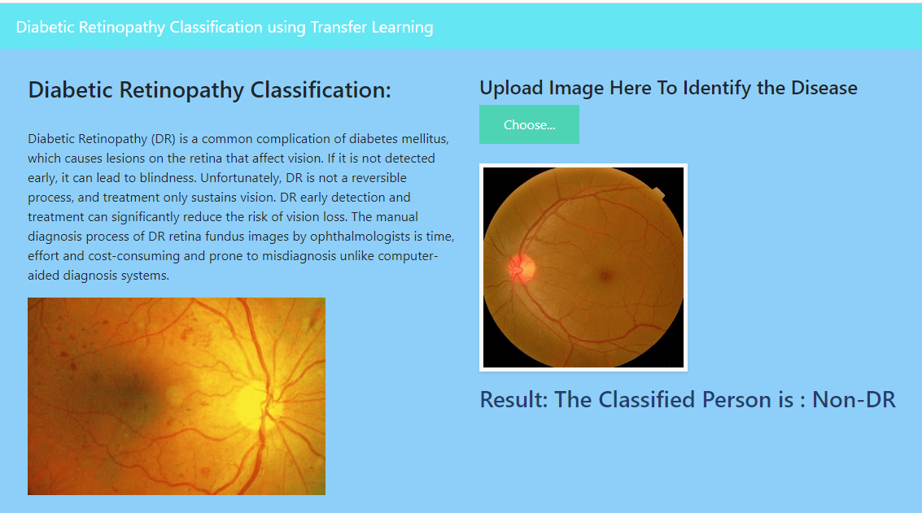

Figure 4 Predicted Output

**6 ADVANTAGES AND DISADVANTAGES**

**5.1 Advantages**

The automated nature of the deep learning model accelerates the screening process, reducing the burden on healthcare professionals. Accuracy: Leveraging the power of Xception and transfer learning, the model demonstrates high accuracy in early detection. The model's ability to generalize across diverse fundus images enhances its robustness and real-world applicability.

**5.2 Disadvantages**

Fine-tuning deep learning models, particularly architectures like Xception, can be computationally intensive, demanding substantial computational resources. The model's performance is highly dependent on the quality and diversity of the training dataset. Limited or biased data may impact generalization.

**6. CONCLUSION AND FUTURE SCOPE**

In conclusion, the project represents a significant stride in leveraging deep learning, particularly the Xception neural network, for the early detection of diabetic retinopathy, addressing longstanding challenges associated with traditional screening methods. The user-centric design ensures seamless interaction between healthcare professionals and the automated system, fostering accessibility and usability. The theoretical analysis outlines a systematic approach, emphasizing the interconnected components of data pre-processing, model building, and application development. The experimental investigations underscore the importance of a diverse and high-quality dataset, effective data pre-processing techniques, and the successful implementation of the Xception model, achieving a commendable validation accuracy of 87%.

Looking ahead, the future scope of the project includes exploring ensemble models to enhance performance, incorporating explainability techniques for transparency, real-time implementation for swift clinical decisions, addressing ethical considerations, and integrating the system with existing healthcare infrastructure. This project lays a robust foundation, showcasing the potential of deep learning in diabetic retinopathy detection, while future advancements hold the promise of further refining and expanding the technology's impact in the realm of medical image analysis.

**REFERENCES**

1. Oh, K.; Kang, H.M.; Leem, D.; Lee, H.; Seo, K.Y.; Yoon, S. Early detection of diabetic retinopathy based on deep learning and ultra-wide-field fundus images. Sci. Rep. 2021, 11, 1897.
2. Sahlsten, J.; Jaskari, J.; Kivinen, J.; Turunen, L.; Jaanio, E.; Hietala, K.; Kaski, K. Deep Learning Fundus Image Analysis for Diabetic Retinopathy and Macular Edema Grading. Sci. Rep. 2019, 9, 10750.
3. Gadekallu, T.R.; Khare, N.; Bhattacharya, S.; Singh, S.; Maddikunta, P.K.R.; Ra, I.-H.; Alazab, M. Early Detection of Diabetic Retinopathy Using PCA-Firefly Based Deep Learning Model. Electron. 2020, 9, 274.
4. Bilal, A.; Sun, G.; Li, Y.; Mazhar, S.; Khan, A.Q. Diabetic Retinopathy Detection and Classification Using Mixed Models for a Disease Grading Database. IEEE Access 2021, 9, 23544–23553
5. Mansour, R.F. Deep-learning-based automatic computer-aided diagnosis system for diabetic retinopathy. Biomed. Eng. Lett. 2017, 8, 41–57.
6. Elswah, D.K.; Elnakib, A.A.; Moustafa, H.E.-D. Automated Diabetic Retinopathy Grading using Resnet. In Proceedings of the National Radio Science Conference, NRSC, Cairo, Egypt, 8–10 September 2020; pp. 248–254.
7. Sandhu, H.S.; Elmogy, M.; Sharafeldeen, A.; Elsharkawy, M.; El-Adawy, N.; Eltanboly, A.; Shalaby, A.; Keynton, R.; El-Baz, A. Automated Diagnosis of Diabetic Retinopathy Using Clinical Biomarkers, Optical Coherence Tomography, and Optical Coherence Tomography Angiography. Am. J. Ophthalmol. 2020, 216, 201–206.
8. Ali, A.; Qadri, S.; Mashwani, W.K.; Kumam, W.; Kumam, P.; Naeem, S.; Goktas, A.; Jamal, F.; Chesneau, C.; Anam, S.; et al. Machine Learning Based Automated Segmentation and Hybrid Feature Analysis for Diabetic Retinopathy Classification Using Fundus Image. Entropy 2020, 22, 567.
9. Gulshan, V.; Peng, L.; Coram, M.; Stumpe, M.C.; Wu, D.; Narayanaswamy, A.; Venugopalan, S.; Widner, K.; Madams, T.; Cuadros, J.; et al. Development and Validation of a Deep Learning Algorithm for Detection of Diabetic Retinopathy in Retinal Fundus Photographs. JAMA 2016, 316, 2402–2410
10. Gargeya, R.; Leng, T. Automated Identification of Diabetic Retinopathy Using Deep Learning. Ophthalmology 2017, 124, 962–969
11. Rajalakshmi, R.; Subashini, R.; Anjana, R.M.; Mohan, V. Automated diabetic retinopathy detection in smartphone-based fundus photography using artificial intelligence. Eye 2018, 32, 1138–1144.
12. Riaz, H.; Park, J.; Choi, H.; Kim, H.; Kim, J. Deep and Densely Connected Networks for Classification of Diabetic Retinopathy. Diagnostics 2020, 10, 24.